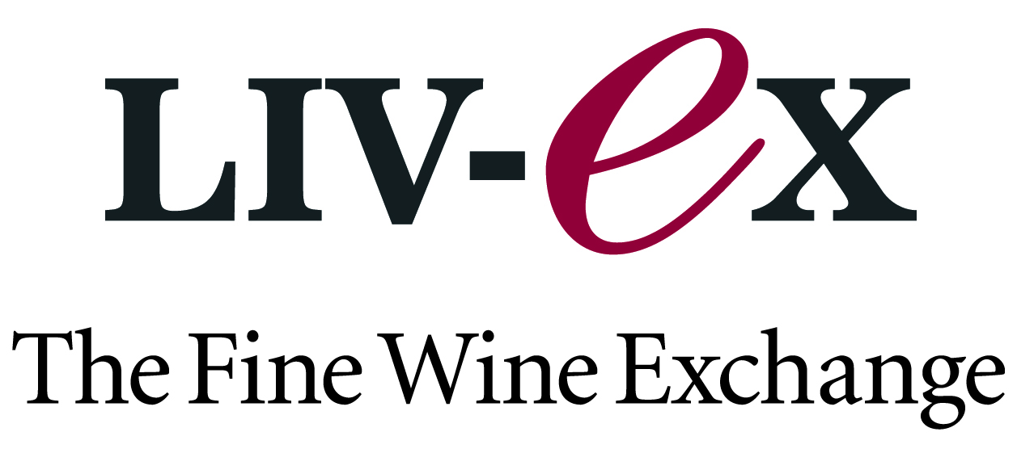

CARRYQUOTE PARTNERS WITH FINE WINE EXCHANGE, LIV-EX

New Alliance Makes Fine Wine Price Information More Accessible to the Investment Community

Zug, Switzerland / New York, NY, U.S.A – January, 26 2010 – CarryQuote®, A.G., a pioneer in integrated desktop and mobile financial information solutions, today announced that it has partnered with Liv-ex – The Fine Wine Exchange.

With members in 24 countries on four continents, Liv-ex.com is the world’s leading wholesale marketplace for fine wines. Its database holds more than four million lines of fine wine price data, with 150,000 new lines added each month, making it the leading source of independent market information for both professional traders and collectors.

said James Miles, Director, Liv-ex.

“By offering fine wine investment data from Liv-ex, we are advancing our goal of providing customers with the most comprehensive and dynamic package of global investment data for the price available on the market today,” said Michael Stennicke, CEO, CarryQuote. “Investors looking for variation from stocks, bonds and currencies are trying fine wine, which has consistently provided good returns over time.”

About CarryQuote
CarryQuote is the first and only mobile financial information services company to provide cost-effective, real-time pricing data, actionable analytics, and personalized alerts through an easy-to-use interface, accessible on any Smartphone, including Blackberry®, iPhone®, Symbian®, and Windows Mobile®. CarryQuote’s real-time snapshot market views and personalized alerts ensure that fund managers, wealth managers and individual investors are always on top of market changes and have visibility into global market data from more than 80 global data sources covering a broad range of asset classes, including equities, bonds, foreign exchange, commodities, real estate and alternative investments. CarryQuote is headquartered in Zug, Switzerland, and has offices in New York, Hong Kong, and Shenzhen (China). For more information, please visit www.carryquote.com. Sign up for a 30-Day Free Trial of CarryQuote at: https://pro.carryquote.com/pr3

About Liv-ex:
The Liv-ex (The London International Vintners Exchange) is the leading exchange for fine wine. Established in 1999, Liv-ex provides an integrated and fully comprehensive trading platform, bringing new standards of efficiency and transparency to a traditionally opaque market. Liv-ex also provides valuation services and sells data to both professional traders and wine collectors. Its price benchmarks include: The Liv-ex 100 Fine Wine Index, which calculates the monthly price movement of 100 of the world’s most sought-after fine wines; The Liv-ex Claret Chip Index, which tracks weekly the top scoring Bordeaux First Growths from the last fifteen years; The Liv-ex Fine Wine Investables Index, which tracks monthly the most ‘investable’ wines in the market (200 wines from the 24 top Bordeaux chateaux). More information is available at: http://www.liv-ex.com/

Contact:
Erika Freed
Zer0 to 5ive
917-359-7974
Erika@0to5.com

###

